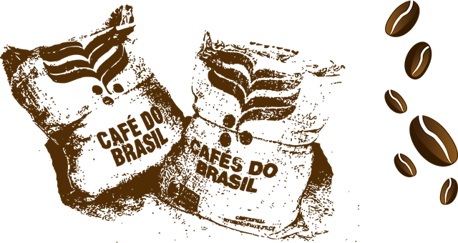

COFFEE BEAN SUPPLIER
SALES PROPOSAL
(with a special discount inside)

Prepared for:
{{customerName}}
{{customerCompany}}
{{customerEmail}}
{{date}:format(dd.MM.yyyy)}

About Us
Coffee Bean Company helps to solve all “coffee issues”:
- Supplies of high-quality coffee beans
- Choice of coffee equipment
- Repair of coffee machines or grinders
- Train Staff
- Draw up a coffee map for your coffee shop
Product
- Guatemala Fancy
A balanced coffee with nutty, chocolate, and caramel notes. The aftertaste has a slight hint of orange peel.
- Brazil Santos
Suitable for espresso and goes well with milk. Intense acidity is balanced by notes of cocoa and milk chocolate.
- Vietnam Lan Dong
Virtually no acidity, tart with a slight bitterness on the aftertaste, notes of cocoa.
Pricing
$10 per pound, our packages include 450 or 900 pounds of coffee beans. Custom packages are negotiable.
900-pound packages are given a discount of 3%.
A special discount of 5% is available for you for 2 weeks from this sales proposal date.
Contacts of your personal manager at Coffee Bean company
David Navarro
901-341-2480
d.navarro@coffee.com

